MGX ARC USB Ethernet setup

1. Check interfaces
Run:
ip link
Example from the attached system:
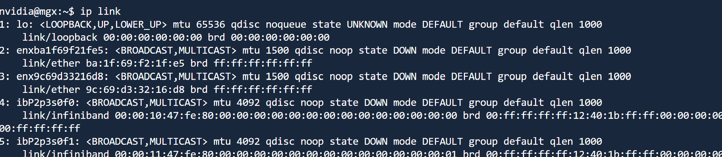
- First MAC: ba:1f:69:f2:1f:e5 on enxba1f69f21fe5.
- Second MAC: 9c:69:d3:32:16:d8 on enx9c69d33216d8.

2. Create or update the netplan YAML
Run:
sudo nano /etc/netplan/99-usbeth.yaml
Paste this and replace the MAC address with the first MAC from ip link:
network:
version: 2
renderer: networkd
ethernets:
usbeth0:
match:
macaddress: "REPLACE_WITH_FIRST_MAC"
set-name: usbeth0
dhcp4: true
dhcp6: false
optional: true
dhcp4-overrides:
route-metric: 100

3. Apply the config
Run:
sudo chmod 600 /etc/netplan/99-usbeth.yaml
sudo netplan try
sudo netplan apply

4. Verify IP
Run:
ip -4 addr show usbeth0

5. If the first MAC does not work
Update the same file and replace the MAC address with the second enx... MAC from ip link, then run again:
sudo netplan try
sudo netplan apply
ip -4 addr show usbeth0

